SIMATS ENGINEERING (SAVEETHA SCHOOL OF ENGINEERING)
Department of Computer Science and Engineering

ASSESSMENT TOOL 2 – Industry Problem Solving Task

Course Code: | CSA06 | Course Title: | Design and Analysis of Algorithms
CO Assessed: | CO4: Articulation (BL4, BL5) | Assessment: | Assessment Tool 2 – Industry Problem Solving Task
Weightage: | 20% of CIA | Total Marks: | 100
CO4 Statement: | Solve optimization problems using dynamic programming and greedy strategies.
Student Name: | N.Srinivas | Reg. No.: | 192372358
Section / Batch: | CSE(AI) | Date: | 22-08-2026

Instructions to Students
- Answer the following question. Total Marks: 100.
- Carefully analyze the given questions.
- Explain in detail with sample code if needed.
- Clearly identify all key issues.
- Provide a thorough analysis with validated results and performance evaluation.

Question Type | Focus Area | Questions
Industry Problem Solving Task | Focus on Solving optimization problems using dynamic programming and greedy strategies | Q1

SECTION A – Industry Problem Solving Task

Code of Conduct
I N.Srinivas(192372358) (Name / Reg No) certify that this submission is my original work and that I have adhered to the guidelines specified for this assessment. I understand that any violation of academic integrity rules will result in disciplinary action.
Signature of the Student: _N.Srinivas________________________

RUBRICS FOR CALCULATION

Industry Problem Solving Task

Criteria | Weightage | Level 4 – Exemplary | Level 3 –  Proficient | Level 2 –  Developing | Level 1 –  Beginning
Understanding of  Industry Problem | 20% | Comprehensive understanding of  real-world problem and constraints | Good understanding with minor gaps in requirements | Basic understanding; some  requirements unclear | Poor understanding; misinterprets problem context
Application of  Engineering  Concepts | 25% | Applies advanced and relevant concepts  effectively to solve the problem | Applies appropriate  concepts with minor errors | Limited application of concepts | Incorrect or no application of concepts
Solution Design | 25% | Innovative, practical, and feasible solution  aligned with industry standards | Logical and feasible solution with minor gaps | Basic solution with limited feasibility | Unclear or impractical solution
Use of Tools | 15% | Effective use of modern tools,  technologies, and real  data | Appropriate use of tools with correct implementation | Limited or inconsistent use of tools | Minimal or incorrect use of tools
Analysis | 10% | Thorough analysis with validated results and performance evaluation | Good analysis with reasonable validation | Basic analysis with limited validation | Poor or no analysis
Professionalism | 5% | Highly professional, well-documented,  and clearly presented  work | Good documentation and presentation | Basic documentation with some gaps | Poor documentation and presentation

Marks Evaluation:
Criteria | Wt. | Level 4 –  Exemplary | Level 3 –  Proficient | Level 2 –  Developing | Level 1 –  Beginning
Understanding of Industry Problem | 20%
Application of Engineering Concepts | 25%
Solution Design | 25%
Use of Tools | 15%
Analysis | 10%
Professionalism | 5%
Total Marks (100):

Faculty In-charge | Course Coordinator | Head of Department
Name: | Name: | Name:
Signature: _______________ | Signature: _______________ | Signature: _______________
Date: ___________________ | Date: ___________________ | Date: ___________________

QUESTION AND SOLUTION:

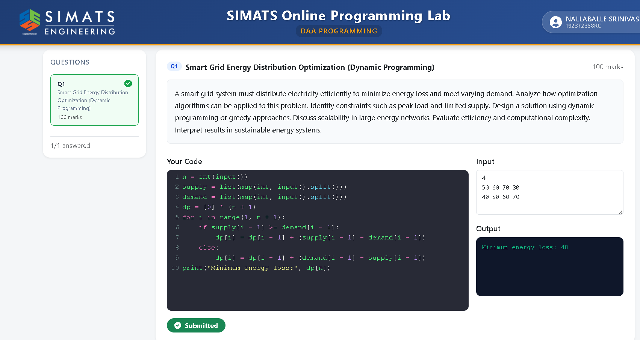

SMART GRID ENERGY DISTRIBUTION:-

Smart Grid Energy Distribution is an advanced system used to generate, distribute, monitor, and manage electrical energy efficiently. It combines traditional power grids with modern technologies such as sensors, smart meters, communication networks, automation, and data analysis. The main purpose of a smart grid is to provide reliable and efficient electricity while reducing energy wastage.

A smart grid continuously monitors electricity generation and consumption. Smart meters collect real-time information about energy usage and send the data to the control system. Based on this information, the system can identify power demand, detect faults, and manage electricity distribution automatically. This helps electricity providers balance energy supply and demand effectively.
Smart grids can also integrate renewable energy sources such as solar and wind power. Energy generated from these sources can be distributed to consumers or stored in energy storage systems for later use. Smart grid technology also supports demand response, where electricity consumption can be adjusted during periods of high demand.

The major advantages of Smart Grid Energy Distribution include reduced power losses, improved reliability, efficient energy management, faster fault detection, and better integration of renewable energy. It also helps consumers understand and control their electricity consumption.

